# Problem Statement

* When SQL executes query, DB Query Optimizer creates Complied Query Plan
* Caches this plan for next usage
* At times using same plan for diff parameters leads to Parameter Sniffing Plan, where for one of the parameter value, execution plan time increases where instead of Index Seek, Entire Cluster Scan happens.
* Solution : Recompile or Optimize SP for best used parameter value.

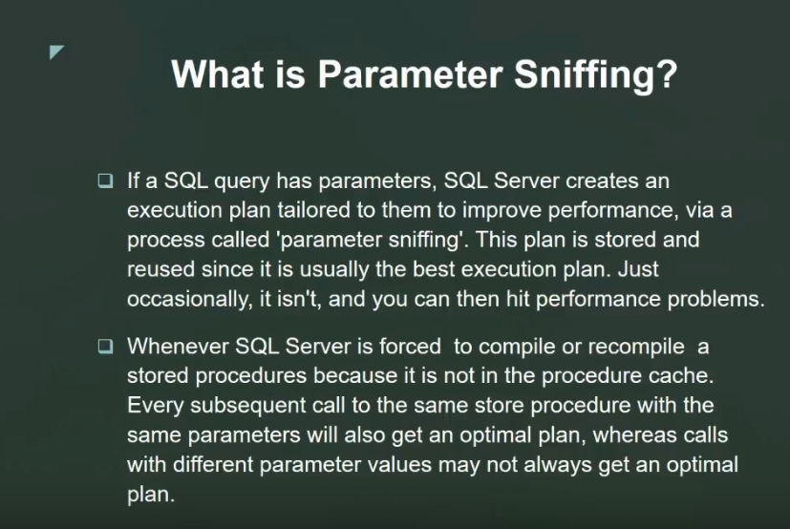

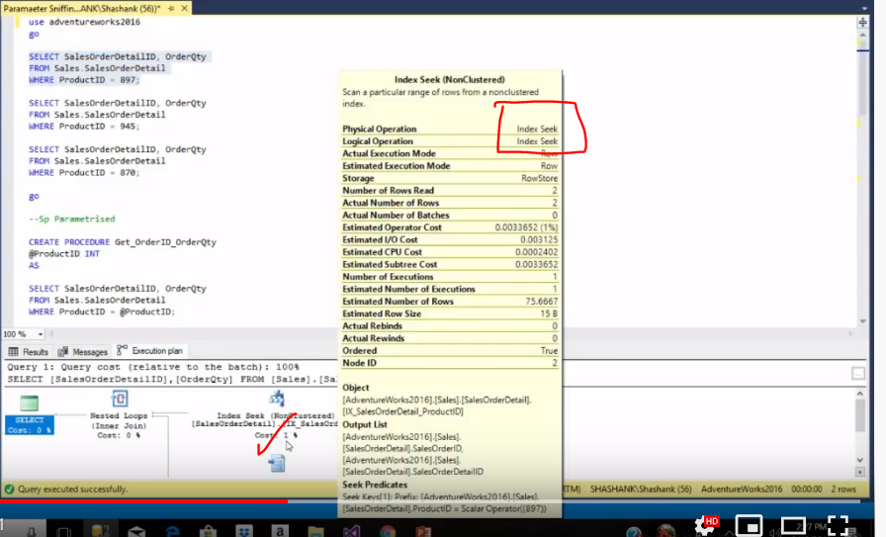

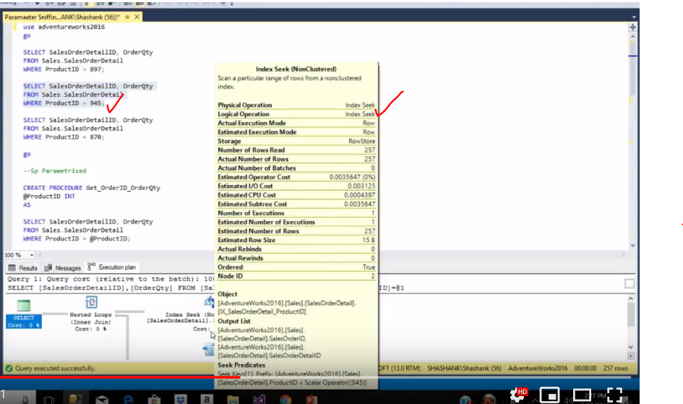

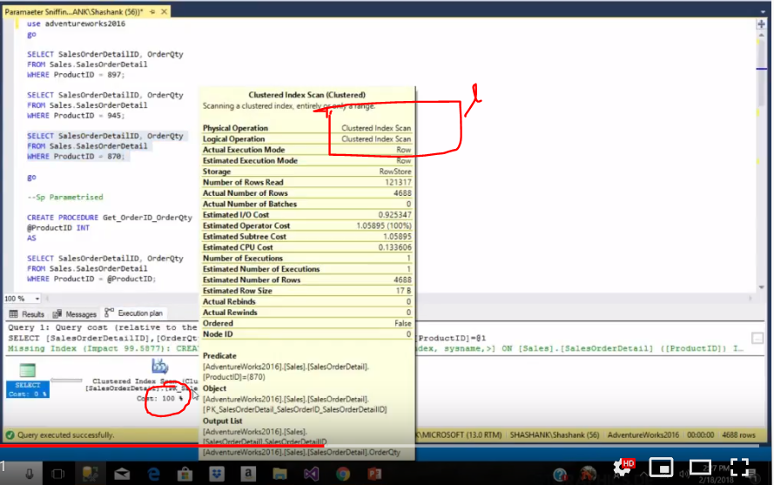

|  |  |
| --- | --- |
|  |  |

|  |  |
| --- | --- |
|  |  |

# Problem Resolution 1 – With Recompile

With this solution, it won’t create new plan and follow best plan of first execution.

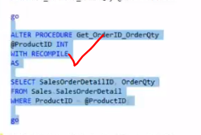

|  |  |
| --- | --- |
|  |  |

|  |  |
| --- | --- |
|  |  |

# Problem Resolution 2 – With Optimize

As mentioned in above problem, for product id 945, it was index seek, so better to optimize SP with that parameters so that for any other parameter it will follow optimized plan.

